P1-EXHUASTIVE ANALYSIS OF INDIAN AGRICULTURE USING POWER BI

1. REMOVE COLUMNS

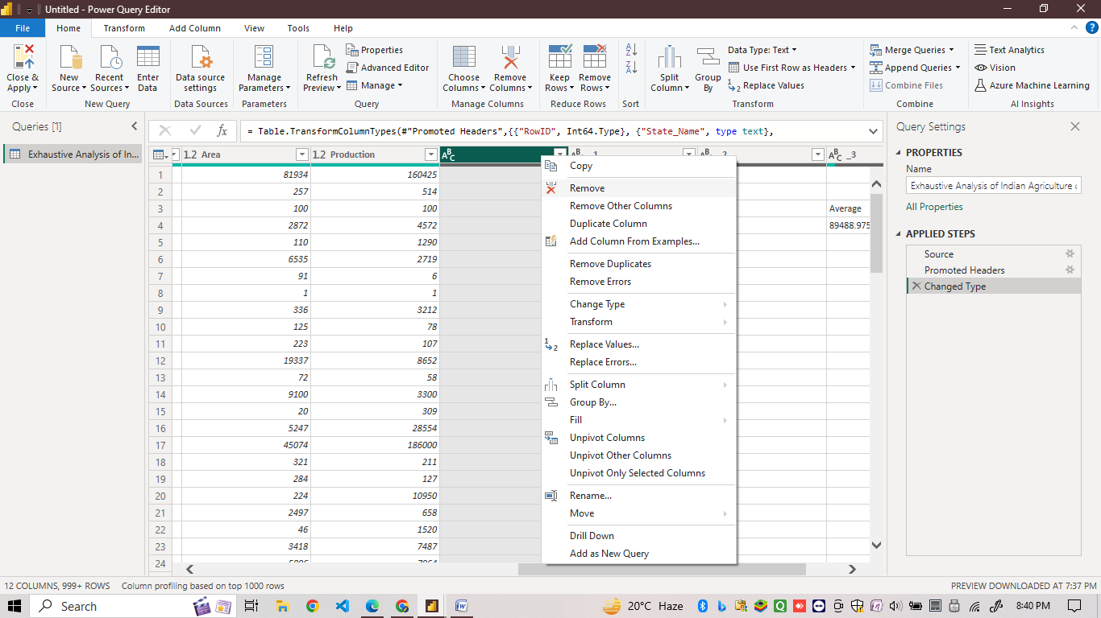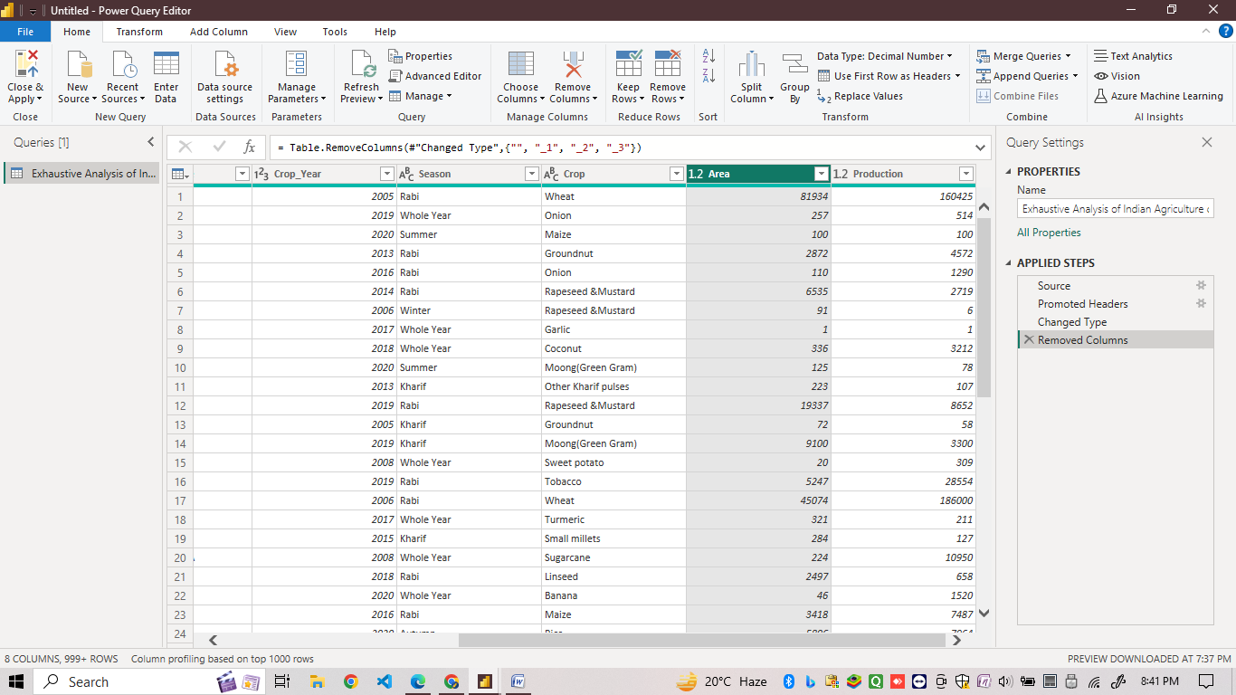

2.TO CHECK IF DATA CONTAINS NULL VALUE OR NOT .

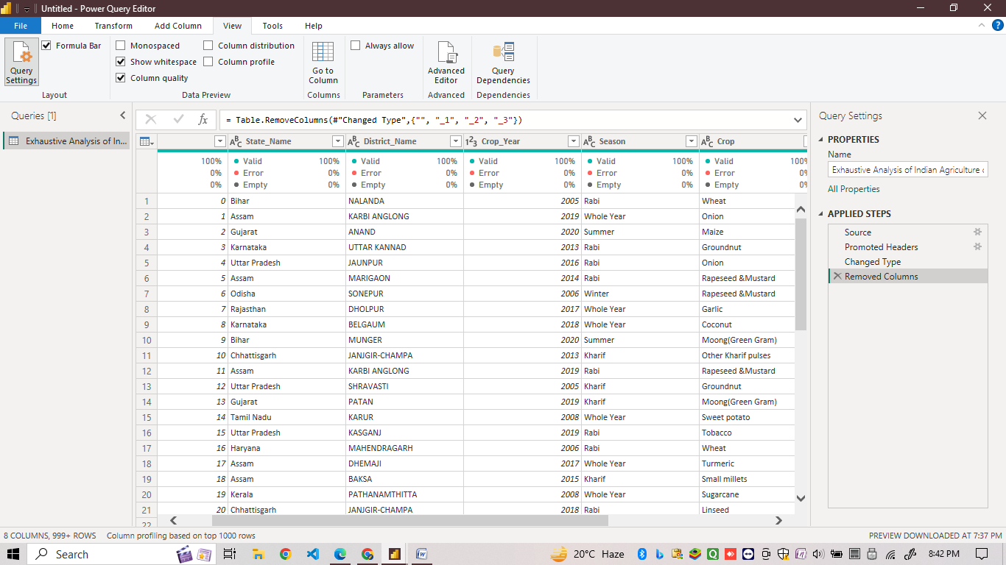

3. TO REMOVE BLANK ROWS

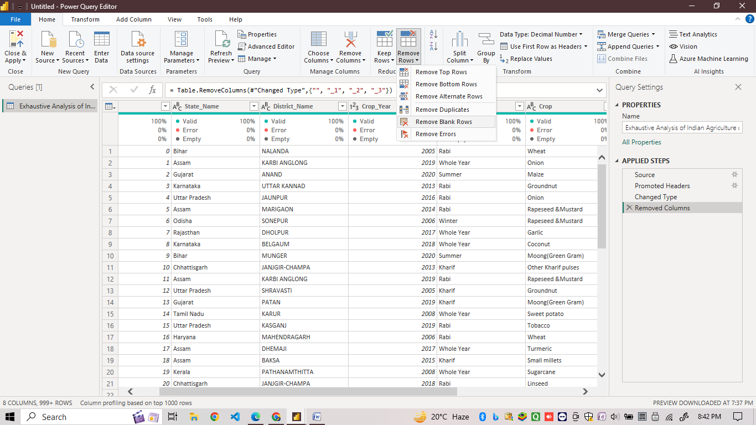

4.TO REMOVE DUPLICATE RECORDS

